Knitting From the Heart Happenings!
 | CLASS | * | Dates & Times | Description
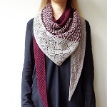 | Laurelie  With Karen | *3 | Tuesdays, January 14 & 28, Feb 11  OR  March 3, 17, & 31  6-8 pm  $40 plus supplies  Yarn 15% off! | Back for more! This one was a hit so we are offering it again! We were so inspired when we came across Laurelie! This fingering weight shawl incorporates garter, mosaic and lace knitting.
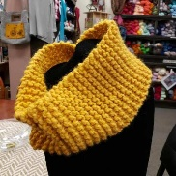 | Learn to Knit  Let’s Knit! (Beginner)  With Diane Augustin | *1 | Choose your session  Let’s Knit!  Beginner or refresher  Tuesdays, February 4 & 11 6-8 pm  Tuesdays, February 18 & 25 1- 3 pm  Wednesdays, March 4 & 11 6-8 pm  Wednesdays, March 18 & 25 1-3 pm  Tuesdays, April 21 & 28 6-8 pm  $30 plus supplies Yarn 15% off! | Let’s Knit:  Level 1 beginner or refresh your skills.  This is an introduction to casting on, knitting and purling.
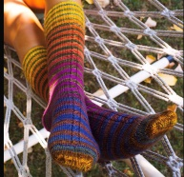 | Intermediate Socks  With Barbara Rees | *3 | Thursdays  January 16, 30, & February 13  OR  March 12, 19 & 26  10:30-12:30 pm  $40 plus supplies  Yarn 15% off! | Take the next step in making socks. Learn to knit using magic loop, Flexiflips, mini needles or stick with double points. Option to add patterning for cuff and body. Create a unique pattern on your heels.
 | Introduction to Socks  With Barbara Rees | *2 | All Thursdays,  January 16, 30, Feb 13  OR  March 12, 19, & 26  1-3 pm  $40 plus supplies  Includes pattern  Yarn 15% off! | Ready to go beyond making hats?  This class is for those ready to take the next step in knitting in the round.
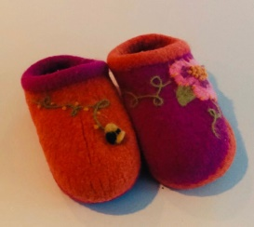 | Embellish Your Felted Clogs  With Marie Mayhew | *2 | Saturday, February 15  10 am to noon  $18 plus supplies | What a treat!  Spend a couple of fun hours with Marie embellishing your felted clogs.  Learn fun new techniques and take the fear out of adding beautiful designs.  It doesn’t matter when you made these clogs, just bring in your finished felted pair and have a great morning playing with us!  Please, just clogs will be embellished at this time.
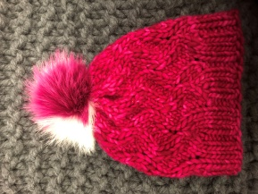 | The Rapture Hat  With Diane Augustin | *2 | Fridays, February 14 & 21  1-3 pm  $30 plus supplies  US 13 16” circular and dpn’s  15% off yarn | Make a super bulky and quick hat!!  This class is for an advanced beginner to learn a fun stitch, knit in the round and decrease with double points.
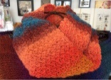 | Let’s Crochet  With Diane Augustin | *1 | Mondays, February 17 & 24  1-3 pm  OR  Tuesdays, March 24 & 31  6-8pm  $30 plus supplies.  Yarn 15% off! | Crochet is “Hot Right Now!!”  Learn how to crochet a scarf or refresh your skills.  Get the basics in this class and have a blast!! You’ll be HOOKED!  Worsted weight yarn, size I hook.
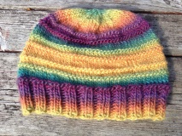 | Let's Knit On!  With Diane Augustin | *2 | Wednesdays, January 29 & February 12  6-8 pm  $30 plus supplies | Let's Knit On!  Are you ready for the next step?  Learn to knit a hat using circular and double point needles.  Must know how to cast on, knit and purl.
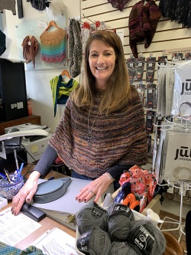 | Let’s Knit a Poncho!  With Diane Augustin | *2 | Wednesdays, February 5 & 19  6-8 pm  $30 plus supplies | This is a new pattern by Diane Augustin. It is knit topdown with a unique pattern using yarnovers and increases to create the perfect little piece.
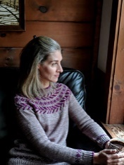 | Chevron Flight  Or  Fern and Feather  With Judy  (FULL) | *3 | 4 week session  Saturday mornings February 8, 29, March 14 & 28  10 am to noon  $55 plus supplies Yarn 15% off | Hot Right Now!  Join Judy in knitting these bottom up colorwork yoke patterns.  Pick your favorite and have a blast!  No seams, only two colors.  This is a great first sweater with colorwork!
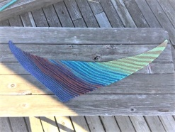 | The Easiest Scarf  With Diane Augustin | *2 | One day session  Tuesday evening March 10  6-8 pm  $18 | Take the fear out of making  your first shawl!  This is a very basic and fantastic way to start shawl knitting.
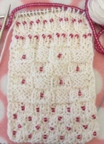 | So, You want to Knit with Beads?  With Diane Augustin | *2 | Saturday, February 22  2-5 pm  $25 plus supplies | Learn to knit with Beads!  Diane is running a workshop to learn how to prestring beads and knit with them. Also learn how to add beads at anytime in your knitting with a crochet hook and a beadle needle.
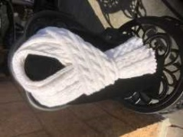 | Palindrome  With Barbara Rees | *2 | Friday, March 13 one session  1-3 pm  $18 plus supplies | Reversible cable technique!  Cables on both sides of this scarf!  The perfect scarf, no matter which way it lays, it looks like the right side.  This is just a one day class to get you started to make this cable scarf.  Great for a man, woman or child!
 | Ergonomic Knitting  With Karen Richtman |  | Saturday, March 21  10 am to noon  $25 | This class is designed for everyone! Knit faster, more comfortably and longer using Karen’s ergonomic tips on how to hold your needles, posture, positions, excercises, stretches and much more!
Let’s Get Together! | Work on your project with a group! All Welcome! |  | Every Wednesday 10 am – Noon  Every Monday & Thursday 6–8 pm | No charge!  Keep our doors open and please work on yarn from our shop!
SOS! | Drop–in Help  Are you stuck? We can help! |  | Every Tuesday & Thursday  3–5 pm | Free with our yarn or $5

*Prerequisites: 1) None, 2) Beginner skills, proficient in long tail cast on, knit and purl stitches.
3) Intermediate skills, Level 2 skills plus. 4) Advanced skills, Level 3 plus
***Class prices do not include supplies. We respectfully ask that supplies are purchased here.***
Call today to sign up (651) 702-0880 or signup online! www.heartknits.com
Sunday: Closed Monday: 12pm-8pm Tues/Wed/Fri: 10am-5:30pm Thursday: 10am-8pm Saturday: 10am-5pm

